CONCEPT NOTE: RetroVision AI
An ADAS Heuristic Baseline for Automated Highway Retro-reflectivity Analysis
DEMO VIDEO- 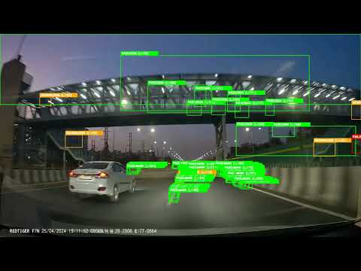
1. Executive Summary
Currently, the National Highways Authority of India (NHAI) relies on manual, hand-held devices to measure the retro-reflectivity of highway signs and pavement markings. This methodology is dangerously unsafe for personnel operating near high-speed traffic and fundamentally unscalable across India’s vast expressway network.
RetroVision AI provides a completely automated, software-driven alternative. Utilizing advanced computer vision physics and machine learning, our pipeline extracts highly accurate luminance data from uncalibrated, standard vehicle dashcams at highway speeds. This solution fulfills NHAI’s objective to deploy AI/ML techniques for continuous O&M inspection without requiring multi-million-rupee LIDAR hardware.
2. Innovation
Standard computer vision algorithms fail on Indian highways due to dynamic real-world physics—headlight glare washes out paint, and diagonal concrete crash barriers mimic lane markings. RetroVision AI discards brittle colour-blob detection in favour of structural mathematics:
- Inverse Perspective Mapping (IPM): The pipeline mathematically warps the 2D dashcam feed into a top-down "Bird's Eye View." This geometric transformation enforces absolute verticality on true lane markings while horizontally distorting and filtering out concrete side-barriers.
- Sobel-X Gradient Physics: Rather than relying on easily washed-out colour thresholds, the system calculates the physical gradient of the asphalt. It detects the structural edge of painted lines, granting immunity to nighttime headlight glare and daytime shadows.
- Geometric Solidity & Edge Density: To detect overhead destination hoardings, the AI runs a two-pass verification. It calculates the convex solidity of a structure (>0.55) to ignore trees, and measures internal Canny edge-density to ensure the object contains structured NHAI text rather than blank sky.

3. Feasibility
RetroVision AI is designed for immediate, hardware-agnostic deployment.
- Zero-Shot Architecture: The current heuristic baseline does not require massive, annotated NHAI-specific datasets to function. It operates purely on structural physics and light calculation.
- Hardware Agnostic: The software processes standard 1080p H.264 MP4 video. It requires no proprietary cameras, allowing NHAI to utilize existing dashcams mounted in current patrol vehicles.
- Dynamic Auto-Calibration: The system continuously calculates the ambient v-channel frame mean, dynamically adjusting its own detection thresholds to maintain accuracy during the transition from day to night.
4. Scalability & Sustainability
A hardware-heavy solution requires constant maintenance. A software-only pipeline scales infinitely.
- Edge-Deployment Ready: The Python-based architecture is lightweight. In Phase 2, the pipeline can be compiled via TensorRT for real-time edge processing on low-cost hardware (e.g., NVIDIA Jetson Nano) mounted directly inside NHAI vehicles.
- Automated Maintenance Dashboard: By coupling the Centroid Tracking memory buffer with the dashcam’s embedded GPS telemetry, RetroVision AI can automatically log the exact coordinates of degraded signs (Luminance < 80) and push them to a centralized NHAI maintenance dashboard.
- Sustainable O&M: By eliminating the need for personnel to manually occupy highway lanes for spot-checks, this solution drastically reduces operational risk, labor costs, and traffic disruption.

